Full Stack Project Report

**On**

**Building a Static Airline Reservation System Site**

**Submitted By-**

**Md Rashid**

**(181500381)**

**Pulkit Ranjan**

**(181500519)**

**Suraj Garg**

**(181500735)**

Department of Computer Engineering & Applications

**Institute of Engineering & Technology**



**GLA University**

**Mathura- 281406, INDIA**

**2020**

**Declaration**

We hereby declare that the work which is being presented in the B.Tech. Project **“Airline Reservation System”**, in partial fulfilment of the requirements for the award ofthe ***Bachelor of Technology*** in Computer Science and Engineering and submitted to the Department of Computer Engineering and Applications of GLA University, Mathura, is an authentic record of our own work carried under the supervision of **Mr. Pankaj Kapoor, Assistant Professor.**

The contents of this project report, in full or in parts, have not been submitted to any other Institute or University for the award of any degree.

Sign: __Md.Rashid__ Sign: __Suraj Garg__

Name of Candidate: Md. Rashid Name of Candidate: Suraj Garg

University Roll No.: 181500381 University Roll No.: 181500735

Sign: _Pulkit Ranjan__

Name of Candidate: Pulkit Ranjan

University Roll No.: 181500519

**Certificate**

This is to certify that the project entitled “Airline Reservation System” has been developed by B.tech students of GLA University, Mathura towards partial fulfilment of the requirements for the award of the degree of Bachelor of Computer Science is a genuine record of the work carried out by Him/her under My Supervision and Guidance and the project report is the original work of student. They have worked on the project Airline Reservation System. They have used CSS, HTML, JAVASCRIPT, Bootstrap and JQuery for the project. Their work is satisfactory. I wish Them all the best for his bright future.

Date: 07/12/2020

Signature of Guide

Place:

Pankaj Kapoor(Assistant Professor)

**Abstract**

The Project describes the Airline Reservation System Site. This report will help you to know in deep the actual work that has been done. The main objective of this application is to represents the Airline Reservation site on online platform via different devices. The client wants to show the presence of their Reservation online. Passengers can see basic pages like services and many and book their journey accordingly. This report shows how the project is designed with the help of designing websites which includes the rough layout of website on the wireframe. Then the report represents all the technologies necessary to develop this website, and how they contributed to build this site. Then the report presents testing analysis of website on different devices just before the final version. At the end this report gives references of the guiding sources for this project.

Acknowledgement

It gives me a great sense of pleasure to present the synopsis of the Full Stack Project (Building a Static Airline Reservation System Site) undertaken during B.Tech. IIIrd Year, this project itself is going to be acknowledgement to the inspiration, drive and technical assistance will be contributed by me.

I owe special debt of gratitude to Mr. Pankaj Kapoor(Assistant Professor, Department of Computer Science and Engineering) for providing me with an encouraging platform to develop this project which thus helped me in shaping my abilities towards a constructive goal and for his constant support and guidance to my work. His sincerity, Thoroughness and perseverance are being a constant source of inspiration for me. He had showered me with all his Extensively experienced ideas and insightful comments at different stages of the project & also taught me about the latest industry-oriented technologies.

Md Rashid (181500381)

Pulkit Ranjan (181500519)

Suraj Garg (181500735)

Contents

|  |  |
| --- | --- |
| Cover and Title  Abstract | I |
| Certificate | ii |
| Abstract | iii |
| Declaration | iv |
| Acknowledgement | v |
| Table of Contents | vi |
|  |  |
| 1. **Introduction** | **1** |
| 1. **Software Requirement Analysis** | **6** |
| 1. **Software Design** | **14** |
| 1. **Testing** | **17** |
| 1. **Implementation and User Interface** | **18** |
| **6. Limitations and Conclusions** | **28** |
| **7. References** | **29** |
|  |  |

Introduction

**About Organisation:**

GLA University is approved and recognized by University Grants Commission, NCTE and Pharmacy Council of India. It has been accredited by the National Assessment and Accreditation Council with ‘A’ Grade. GLA University ranked 1 among all universities present in Mathura, birth place of Lord Krishna.

**About Project:**

The Project is based on Front End Web Development, in this project I have designed and created a Static website or front End of an Airline Reservation. I have used HTML, CSS, JavaScript, Bootstrap and JQuery to develop my website. This website is fully responsive and quite good colours and arrangement of different items.

Airline Reservation System contains the details about flight schedules and its fare tariffs, passenger reservations and ticket records.

Airline Reservation System will hold flight schedules and its fare tariffs, passenger reservations and ticket records. It saves time as it allows online procedure as users no longer to wait in a queue to book the flights. It is automatically generated by the server.

Admin is the main authority who can do addition, deletion, and modification of flights if required.

**Motivation and Objective:**

The main motivation behind this project is eagerness to learn basics of Web Development because I was interested in building of websites. I have always wondered how tiny bits of codes can do all things like this and I always wanted to develop a website.

The Objective was to gain knowledge about web development and learn all technologies related to it like HTML, CSS, JavaScript and Bootstrap and also learn about some inbuilt libraries of CSS. so that I can develop a working website and show everyone that I have learnt something.

As technology advances internet is becoming ever popular. Website has become an essential part. Nowadays it is now very unusual for a business not to have some sort of presence online. With improved connectivity and the advances in Smartphone technologies most people now use the internet to source information, and having your business available to fulfil these information searches is key to driving more footfalls through your door.

A website gives you a controlled way to portray an image of your business as you would like it, giving your customers an idea of the atmosphere and offering before even stepping a foot inside.

**Problem Description**

**Problem Statement:**

Airline Reservation System that were suggested till now, are not up to the desired level. There is no single system which automates all the process. In order to build the system, all the processes in the business should be studied, System study helps us under the problem and needs of the application. System study aims at establishing requests for the system to be acquired, development and installed. It involves studying and analyzing the ways of an organization currently processing the data to produce information. Analyzing the problem thoroughly forms the vital part of the system study. In system analysis, prevailing situation of problem is carefully examined by breaking them into sub problems. Problematic areas are identified and information is collected. Data gathering is essential to any analysis of requests. It is necessary that this analysis familiarizes the designer with objectives, activities and the function of the organization in which the system is to be implemented.

Existing System In few countries if a person wants to book a flight ticket, he use to follow one of these things:

Disadvantages

* Manually goes to the Airport and book his ticket.
* Downloading the ticket form as paper document, filling it manually and submitting it at Airport.
* Fill the Ticket form on system and get the print out as paper documents to submit it at Airport.
* Booking the Ticket at some particular registered ticket counters in online.
* Even above approaches make a ticket booking online, it was not completely done on online. Passenger may not have much freedom over this approach.
* Hence the Passenger may or may not be satisfied with this approach as it includes manual intervention like travelling to Airport for booking his ticket.
* Cannot Upload and Download the latest updates.
* No use of Web Services and Remoting.
* Risk of mismanagement and of data when the project is under development.
* Less Security.
* No proper coordination between different Applications and Users.
* Fewer Use friendly.

**Proposed System:**

The Proposed system ensures the complete freedom for users, where user at his own system can logon to this website and can book his ticket. Our proposed system allows only registered users to book the tickets, view timings and cancel their tickets. In this Proposal the entire work is done on online and ticket with id is also provided for passengers as a print document. Here passengers can send their queries and suggestions through a feedback form. To debug the existing system, remove procedures those cause data redundancy, make navigational sequence proper to build strong password mechanism.

Advantages:

* User friendliness provided in the application with various controls.
* The system makes the overall project management much easier and flexible.
* It provides high level of security with different level of authentication.

Requirement Analysis

**Tools Required:**

For developing my project first, I have to analyse what are the different tools required for developing this project.

**Hardware Required:**

1. A Personal Computer with any Operating System and Internet Connection.
2. With any Processor
3. RAM of computer must be 128 **MB**.
4. Free Disk space of hard disk must be around 20GB.

**Software Requirements:**

1. **Web Browser:** A web browser to run codes and debug and view my work development and use it’s inspect feature and console window.
2. **VS Code:** It’s a platform where I can write my code and maintain my Files.
3. **Git and Git-Hub:** This was required for Hosting my website on internet.
4. **JQuery and Bootstrap:** These are the libraries and framework which will help in easy implementation of CSS in JavaScript.

**Technologies Used:**

1. **HTML5:** HTML5 is a mark-up language used for structuring and presenting content on the World Wide Web. It is the fifth and latest major version of HTML that is a World Wide Web Consortium recommendation.

* HTML is the standard mark-up language for creating Web pages.
* HTML describes the structure of a Web page.
* HTML consists of a series of elements.
* HTML elements tell the browser how to display the content.

1. **CSS3:** Cascading Style Sheets (CSS) is a style sheet language used for describing the look and formatting of a document written in a mark-up language.

* CSS describes how HTML elements are to be displayed on screen, paper, or in other media
* CSS saves a lot of work. It can control the layout of multiple web pages all at once.

1. **JavaScript:**

JavaScript often abbreviated as JS, is a programming language that conforms to the ECMAScript specification. JavaScript is high-level, often just-in-time compiled, and multi-paradigm. It has curly-bracket syntax, dynamic typing, prototype-based object-orientation, and first-class functions.Alongside HTML and CSS, JavaScript is one of the core technologies of the World Wide Web. JavaScript enables interactive web pages and is an essential part of web applications. The vast majority of websites use it for client-side page behaviour, and all major web browsers have a dedicated JavaScript engine to execute it.

1. **Bootstrap:**

Bootstrap is a free and open-source tool collection for creating responsive websites and web applications. It is the most popular HTML, CSS, and JavaScript framework for developing responsive, mobile-first web sites. It solves many problems which we had once, one of which is the cross-browser compatibility issue. Nowadays, the websites are perfect for all the browsers (IE, Firefox and Chrome) and for all sizes of screens (Desktop, Tablets, Phablets, and Phones). All thanks to Bootstrap developers -Mark Otto and Jacob Thornton of Twitter, though it was later declared to be an open-source project.

**Why Bootstrap?**

* Faster and Easier Web-Development.
* It creates Platform-independent web-pages.
* It creates Responsive Web-pages.
* It designed to be responsive to mobile devices too.
* It is Free! Available on [www.getbootstrap.com](http://www.getbootstrap.com)

1. **JQuery:**

jQuery is a lightweight, "write less, do more", JavaScript library.

The purpose of jQuery is to make it much easier to use JavaScript on your website.

jQuery takes a lot of common tasks that require many lines of JavaScript code to accomplish, and wraps them into methods that you can call with a single line of code.

jQuery also simplifies a lot of the complicated things from JavaScript, like AJAX calls and DOM manipulation.

The jQuery library contains the following features:

* HTML/DOM manipulation
* CSS manipulation
* HTML event methods
* Effects and animations
* AJAX
* Utilities

**Modules: Projects has 4 modules.**

**Homepage :-**

* Contains name and logo of the Airline reservation site.
* Contains picture with General Introduction to Company.
* Contains quick navigation to special pages.

**Booking Page:**

* Contains Booking page with information like departure time, date, etc.
* Contains Review Journey page.
* Contains Payment Page

**Admin:**

* Manages Flight and Airbus.

**Contact US:-**

* Contains picture with form to fill for contacting employees.

**SRS**

1. **Introduction**

* Purpose: The main purpose for preparing for preparing this document is to give a general insight into the analysis and requirements of the existing system or situation and for determining the operation characteristics of the system.
* Scope: This document plays a vital role in the development life cycle (SDLC) and it describes the complete requirement of the system. It is meant for use by the developers and will be the basic during testing phase. Any changes made to the requirements in the future will have to go through formal change approval process.

1. **General Description** –

A description about the features of the system.

Product perspective:

This project is mainly towards persons who are willing to travel through Aeroplane. Through this system it will be easier to find a Aeroplane.

* Product functions:

Homepage, Booking, About Us, Contact Us.

* User characteristics:

In here, the passenger can visit the website and understand the information about the reservation site which is written in English language and he/she can interact easily with the website.

* General constraints
* The program will be written in HTML, CSS and JavaScript , Bootstrap and JQuery language.
* The system will mainly running on the URL : **https://mdrashidcs18.github.io/FullStackProject/**
* Assumption & Dependencies:
* Every customer has a mobile phone/tablet/pc.
* Every Passenger is able to read about Aeroplanes and book accordingly.

1. Specific Requirements –

This document is generated as output of requirement analysis. The requirement analysis involves obtaining a clear and through understanding of the product to be developed.

Each requirement in this section should be:

* Correct
* Traceable (both forward and backward to prior/future artefacts)
* Unambiguous
* Verifiable (i.e., testable)
* Prioritized (with respect to importance and/or stability)
* Complete
* Consistent

It has been required that every form’s interface should be user friendly and simple to use.

Designing:

**Wireframe diagram:**

**Homepage layout**

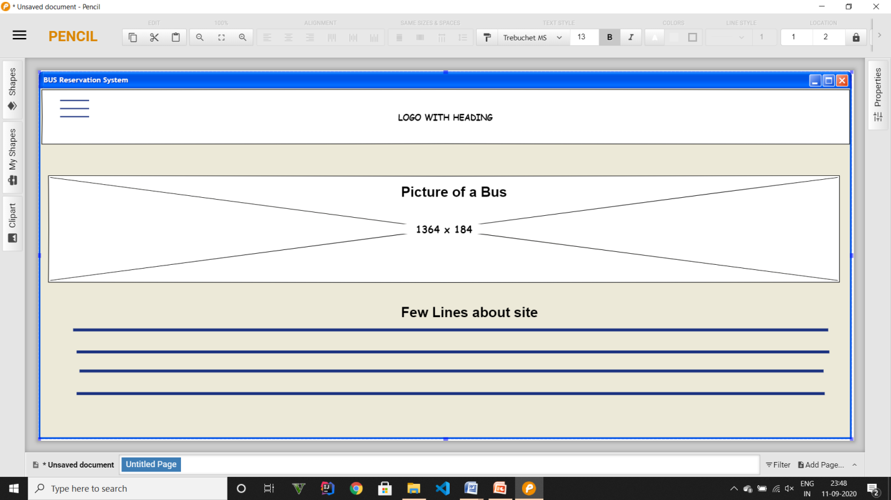

**Booking Page:**

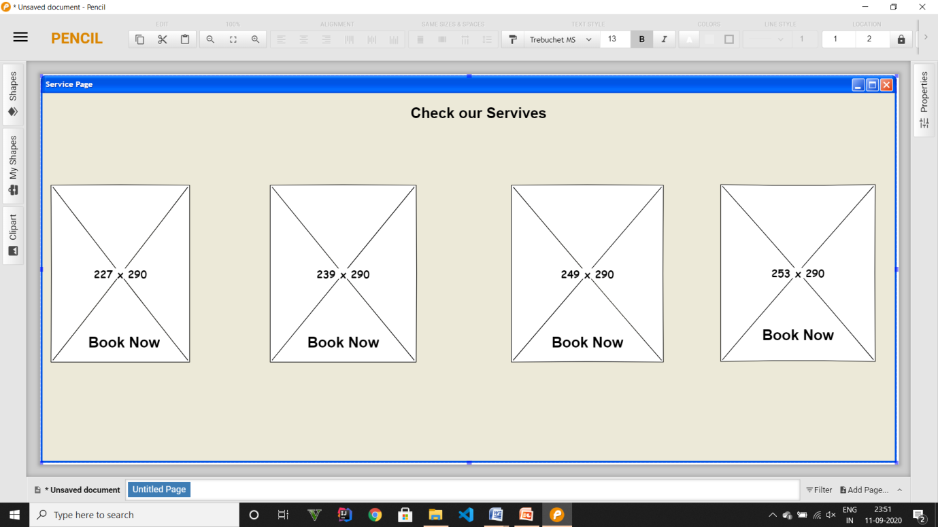

**About Page:**

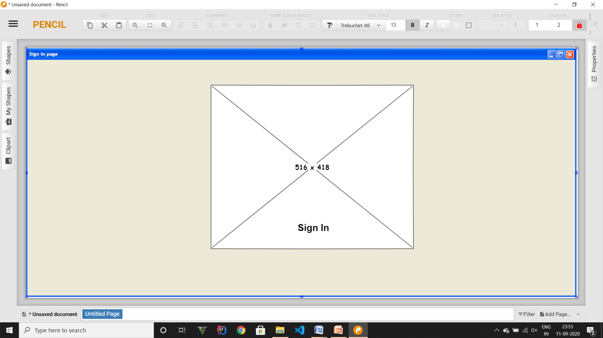

**Contact Us Page**

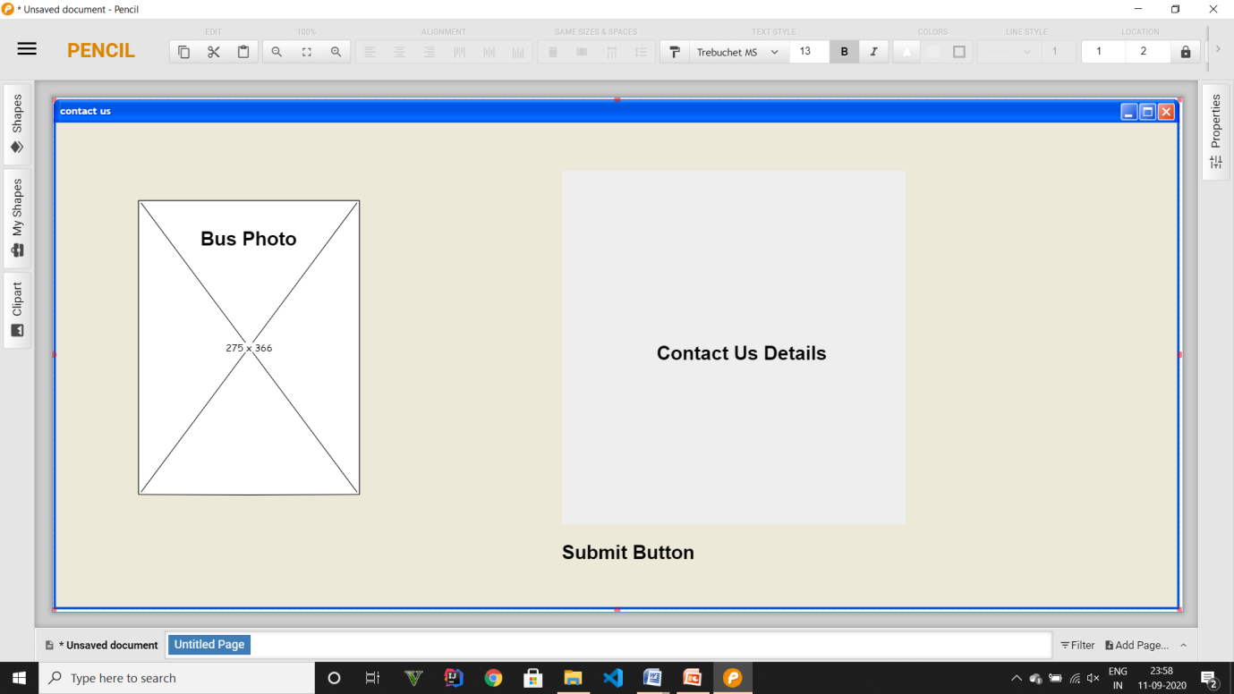

**Testing**

Software testing is a critical element of software quality assurance and represents the ultimate review of specification design and coding. In fact, testing is the one step in the software engineering process that could be viewed as destructive rather than constructive.

A strategy for software testing integrates software test case design methods into a well-planned series of steps that result in the successful construction of software. Testing is the set of activities that can be planned in advance and conducted systematically. The underlying motivation of program testing is to affirm software quality with methods that can economically and effectively apply to both strategic to both large and small-scale systems.

**Strategic Approach to Software Testing**

The software engineering process can be viewed as a spiral. Initially, system engineering defines the role of software and leads to software requirement analysis where the information domain, functions, behaviour, performance, constraints and validation criteria for software are established. Moving inward along the spiral, we come to design and finally to coding. To develop computer software, we spiral in along streamlines that decreases the level of abstraction on each turn.

|  |  |  |  |  |
| --- | --- | --- | --- | --- |
| **Test id** | **Test case title** | **Description** | **Expected Outcome** | **Result** |
| **1.** | Desktop View | All the navigation links are on the header part of the website. | All the contents are arranged and easily visible (range 1300px – 900px of screen) according to the wireframe. | Success |
| **2.** | Mobile View | Sidebar comes in front and focus, | All the contents are arranged and easily visible (range 600px – 300px of screen) | Success |
| **3.** | Entering Flight details | All the navigation links are on the header part of the website. | All the entries are successfully entered. | Success |
| **4.** | Adding New Airbus | Adding of new Flight | New Flights are added successfully | Success |
| **5.** | Admin Login | Admin will login by entering email id and password | Login  successfully | Success |
|  |  |  |  |  |
|  |  |  |  |  |
|  |  |  |  |  |
|  |  |  |  |  |
|  |  |  |  |  |

**Implementation and User Interface**

**User Interface – Here are some Screenshots of the project**

**Home Page**

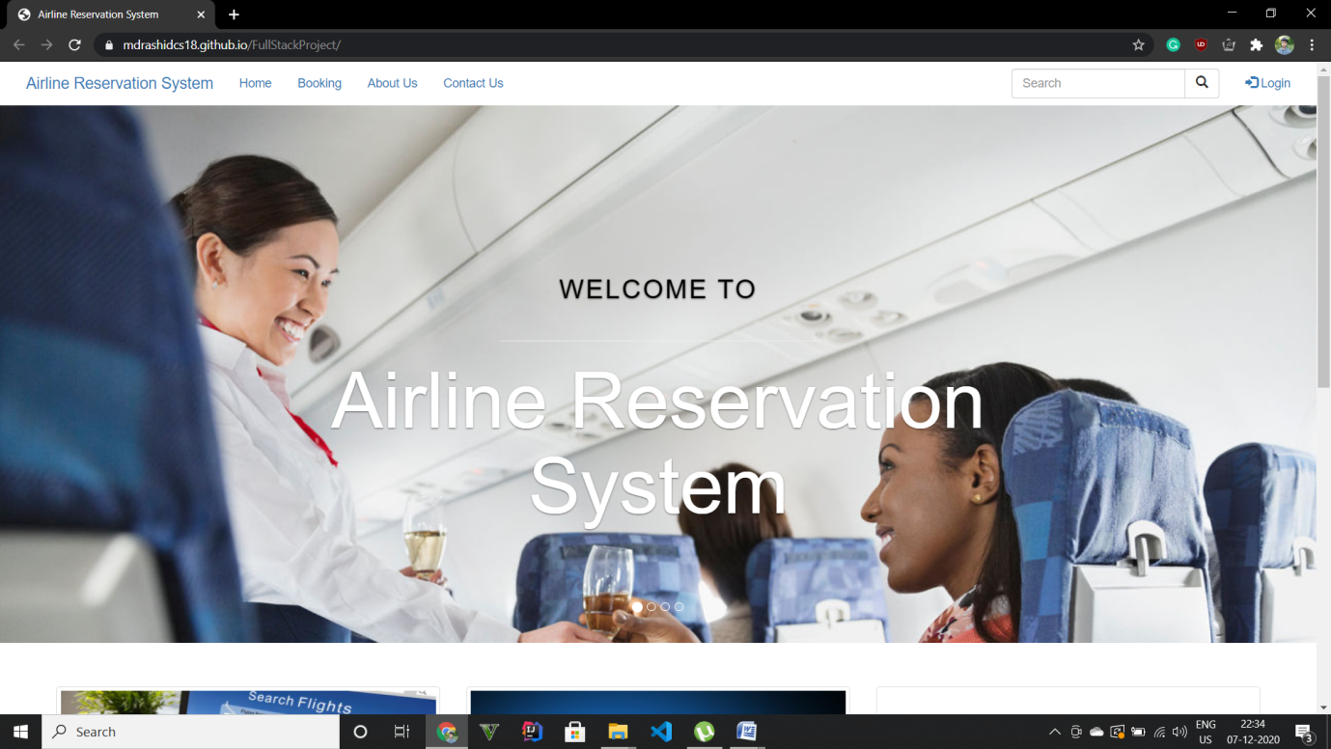

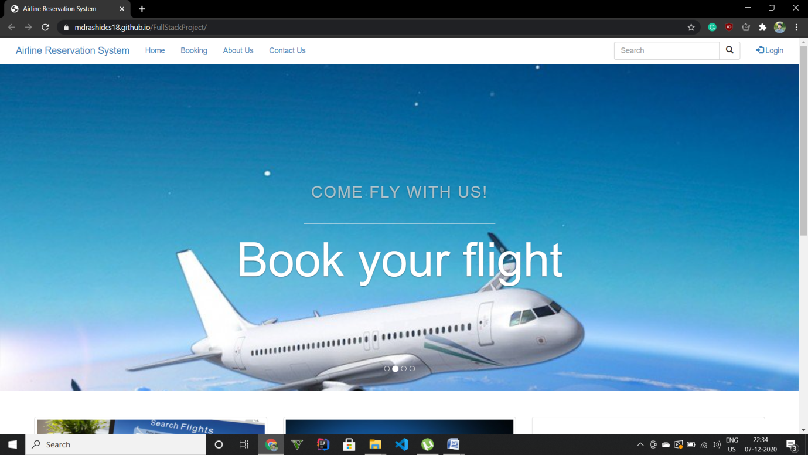

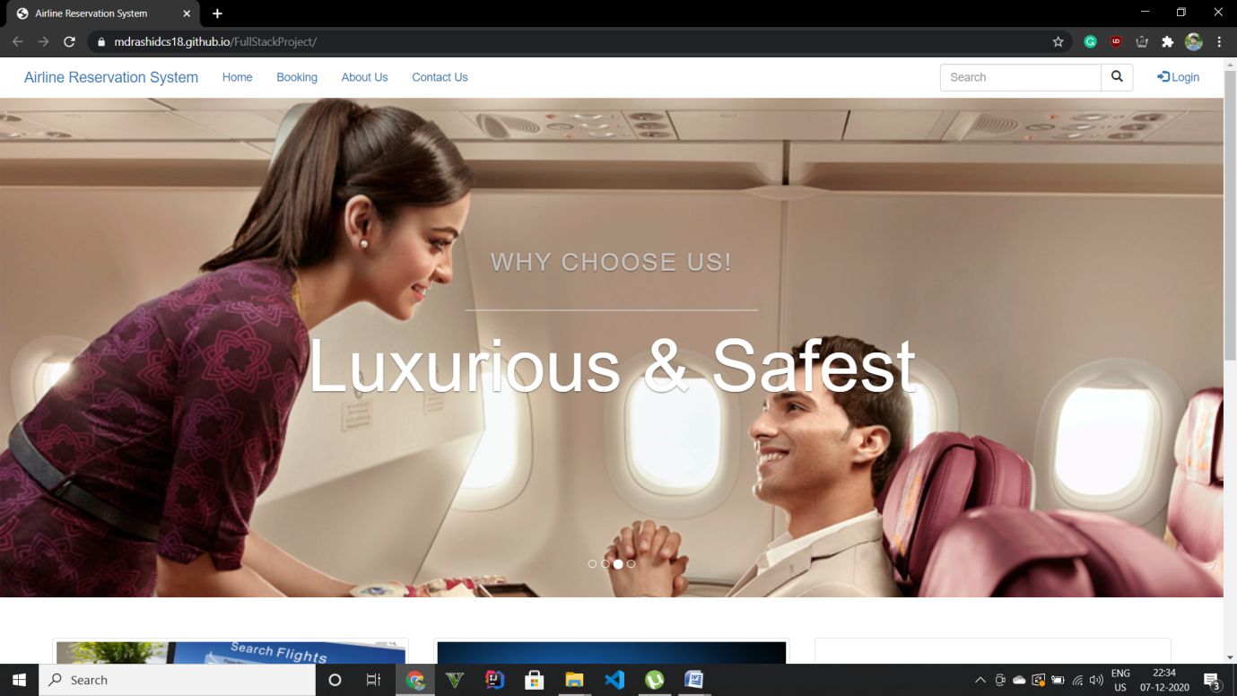

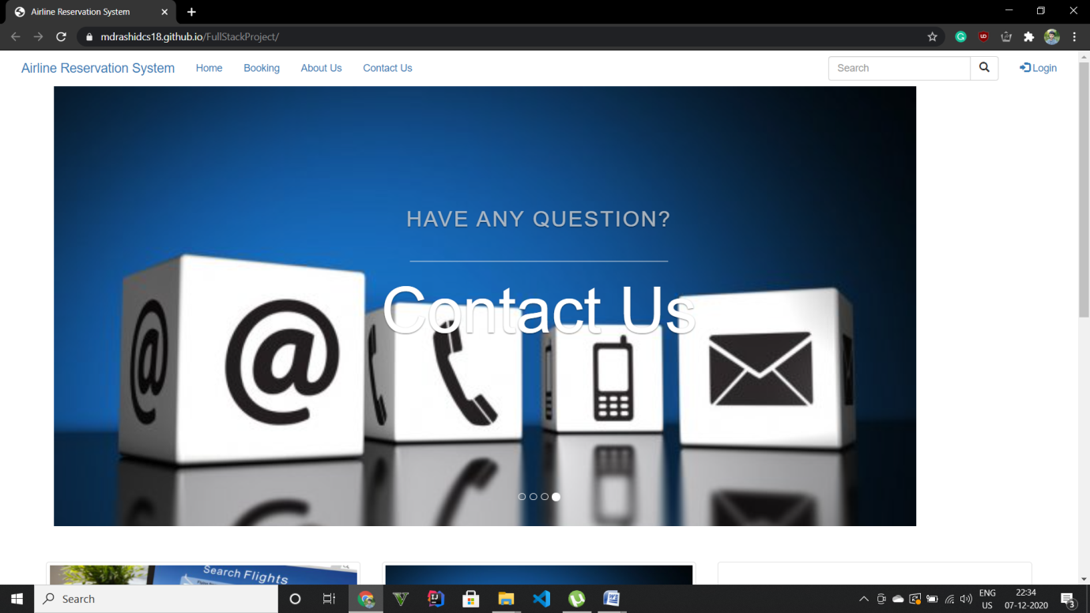

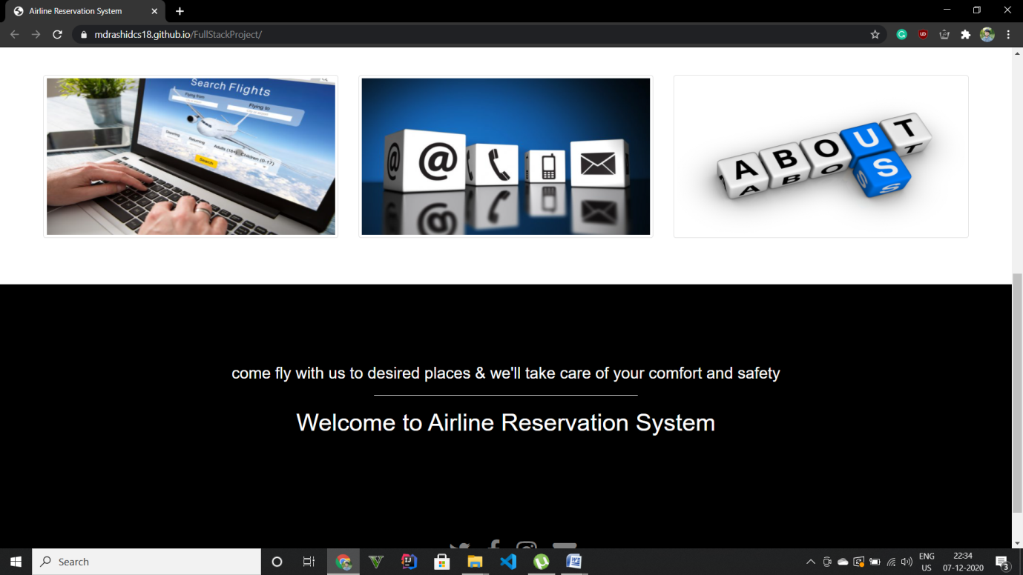

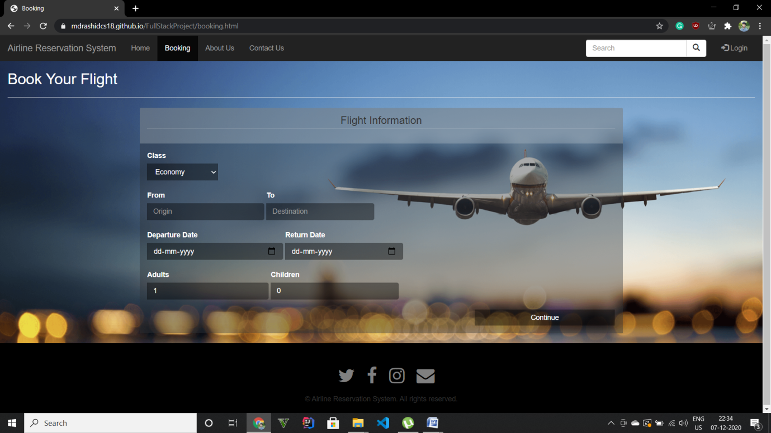

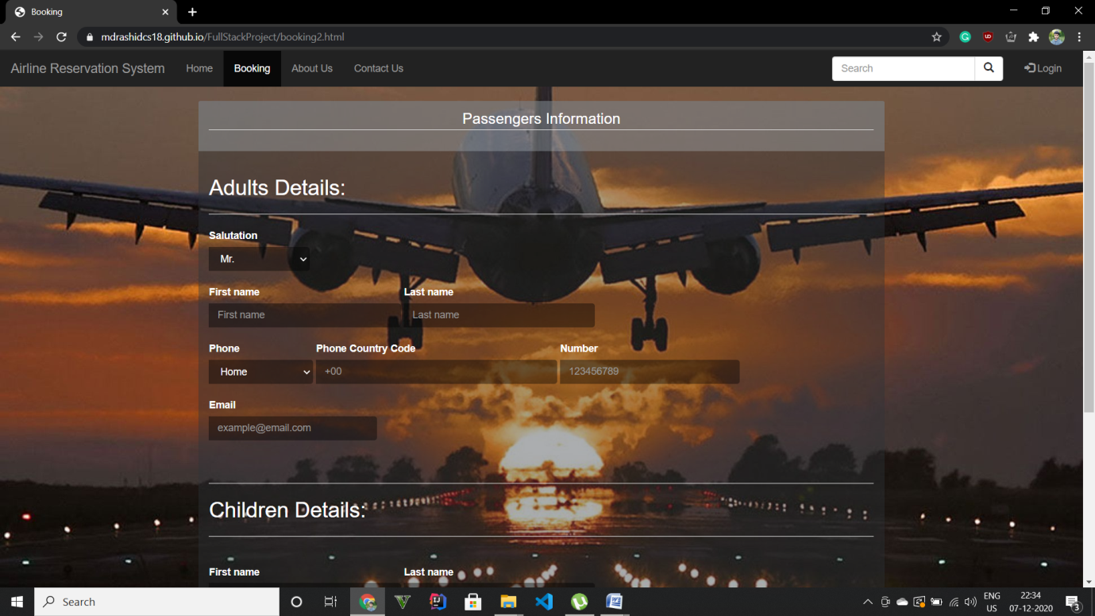

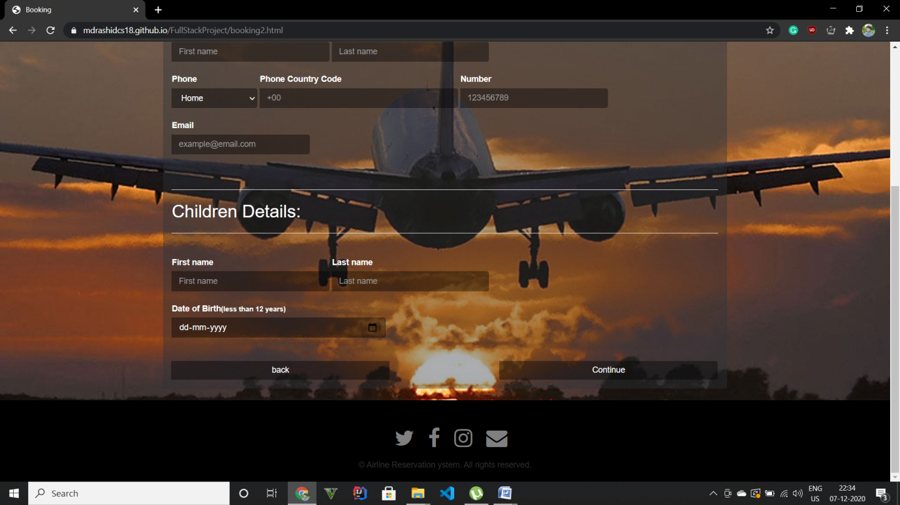

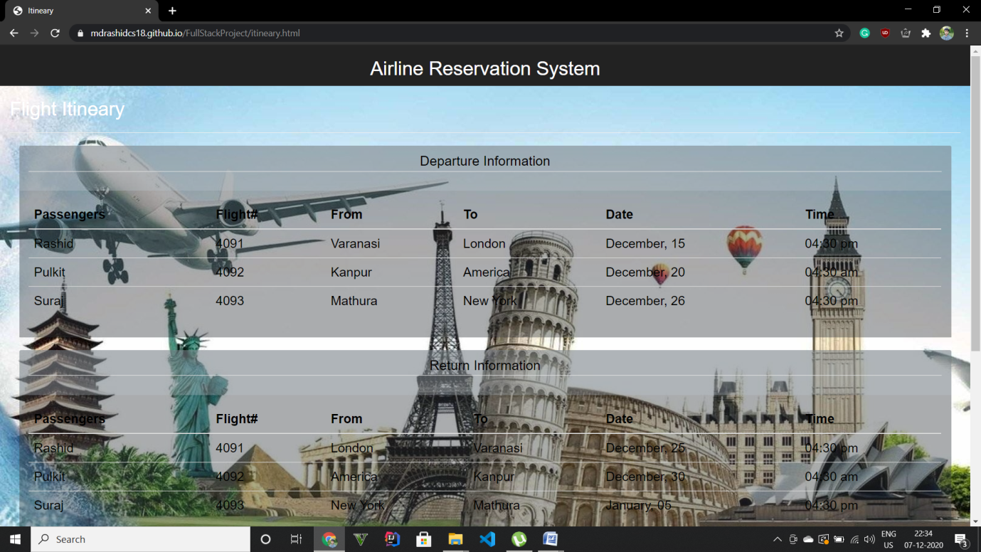

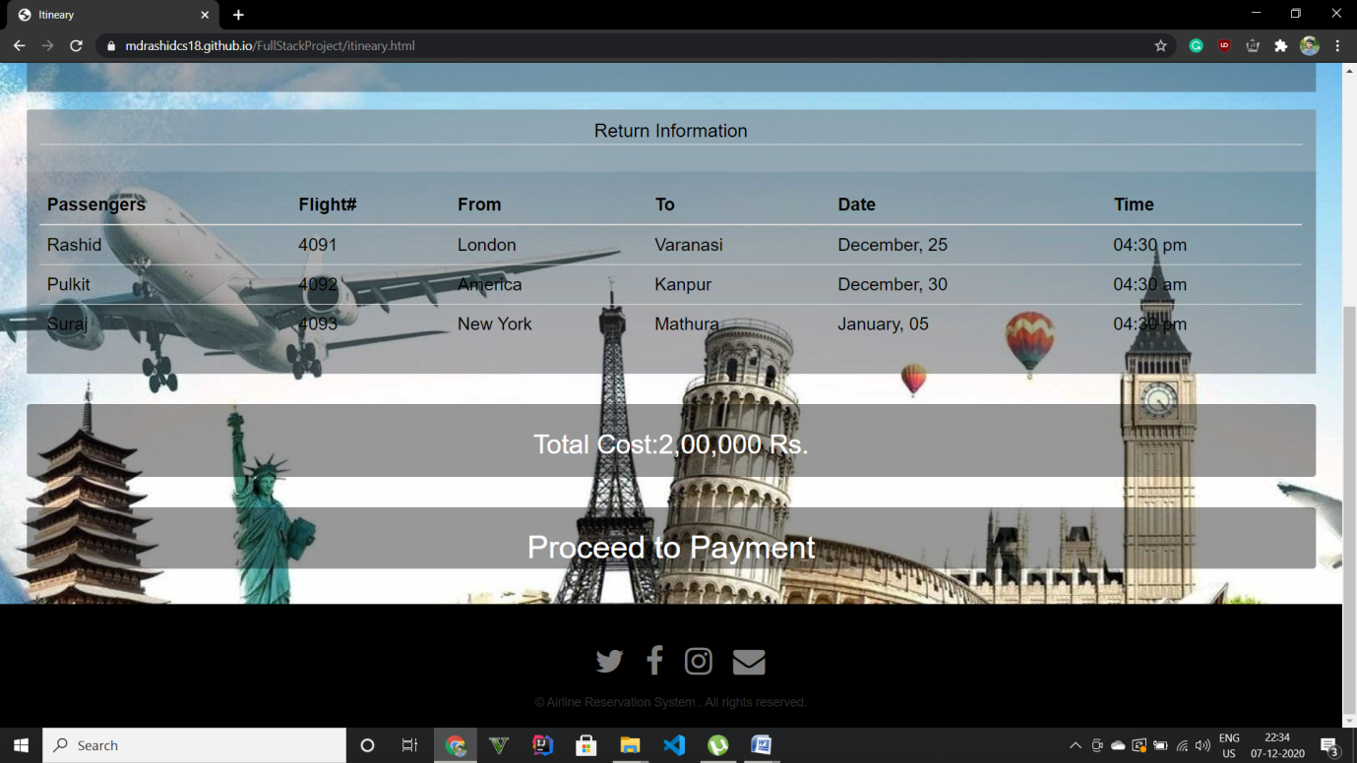

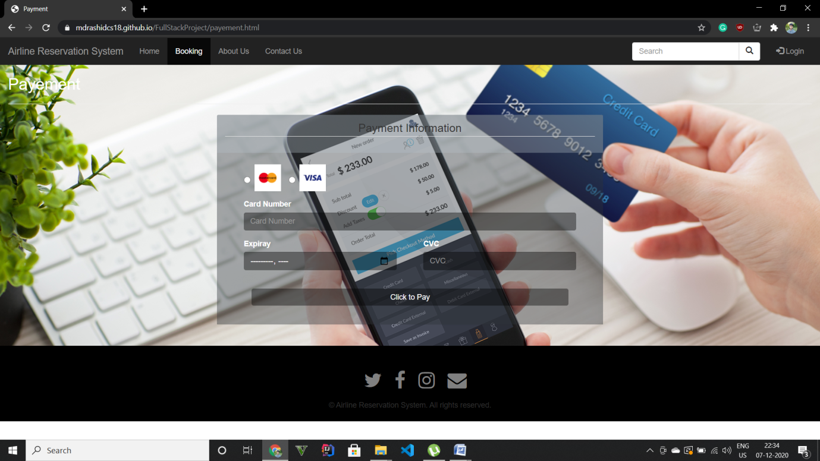

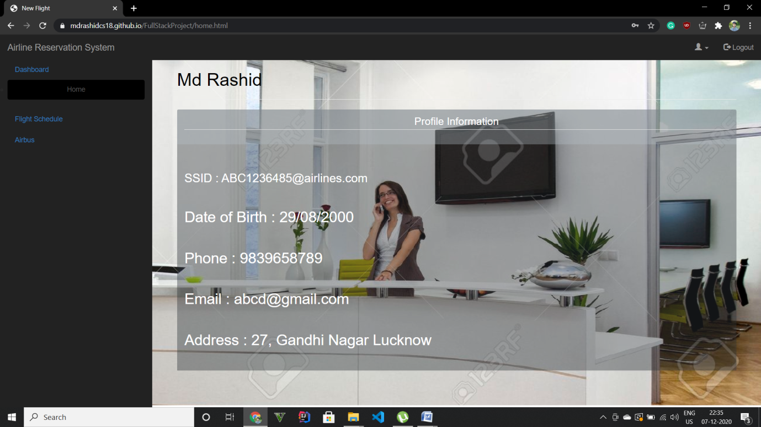

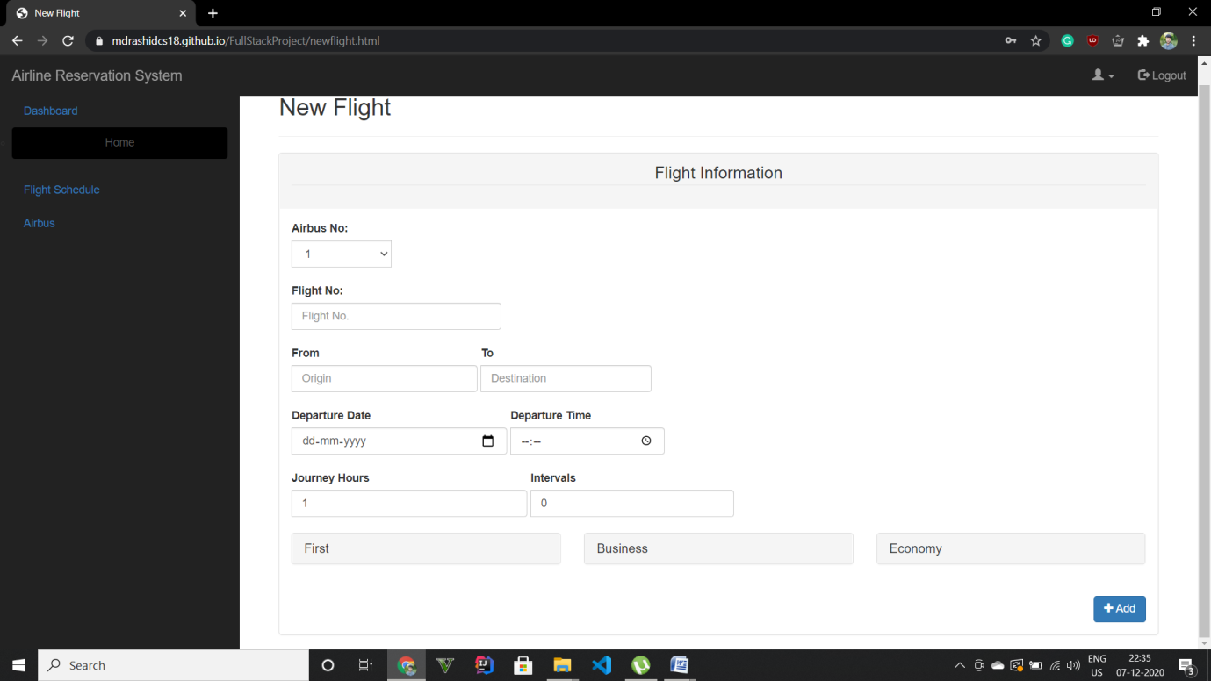

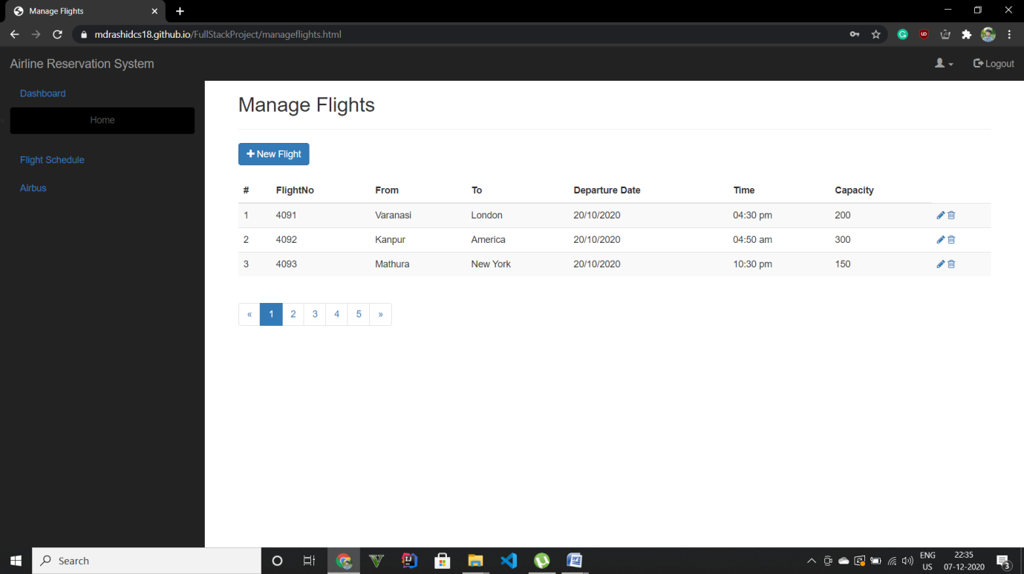

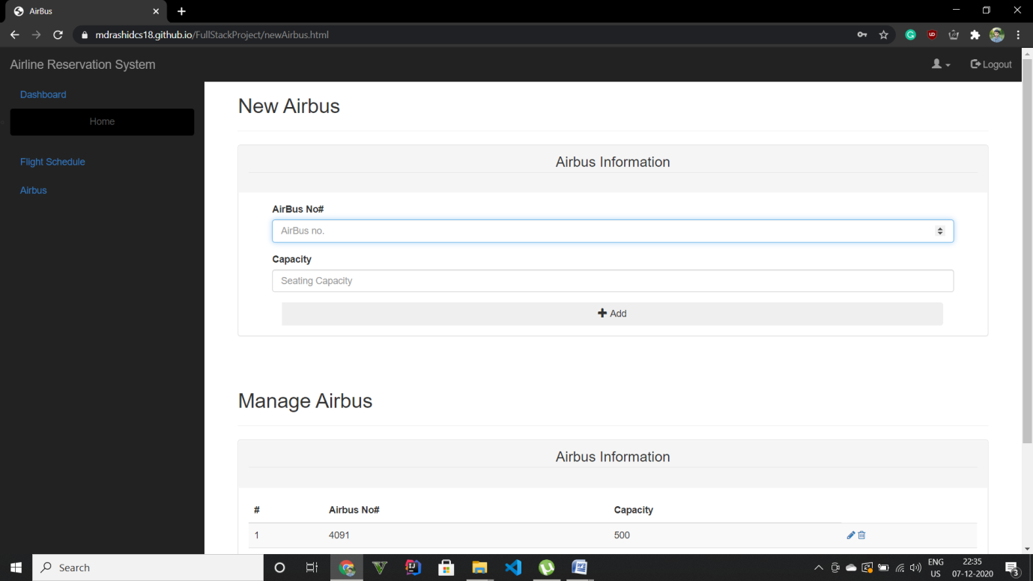

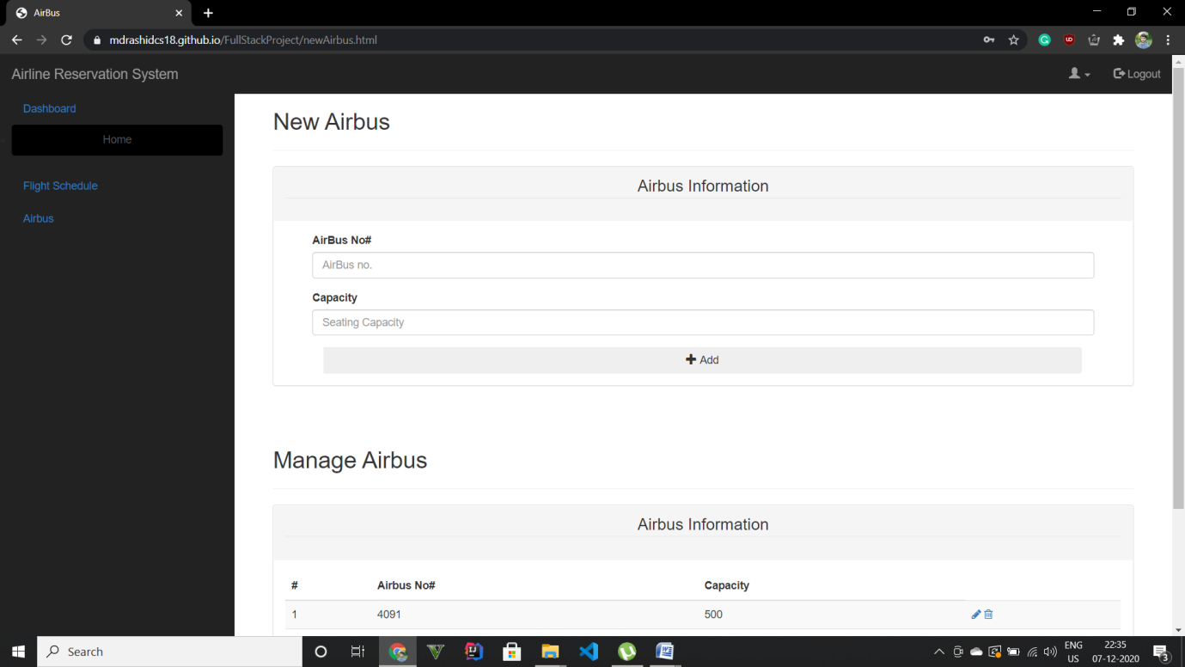

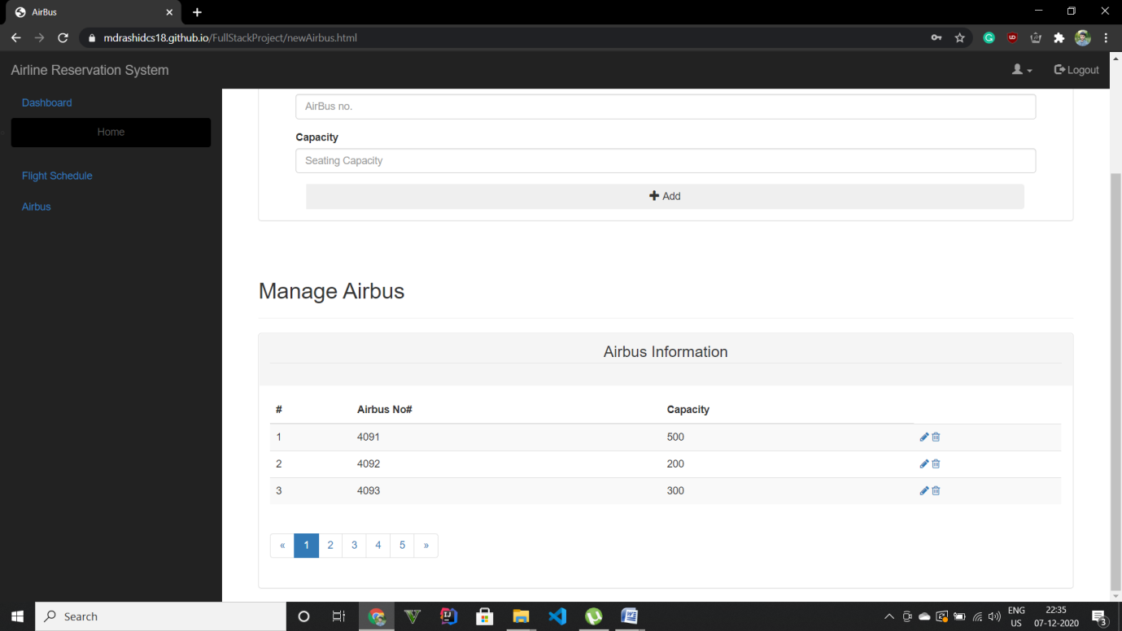

Conclusion:

After coding and building this static website reservation page, I get to learn about different processes related to the development of a website page. The first getting input from the passenger regarding what he wants to get from website then showing him different design and creating design and after approval of it the best part is coding the website it was really fruitful experience and I get to learn many things.

Limitations:

The Limitations of this project is that it was a static website page, it doesn’t update itself in real time and there is not any back-end part to support it to make it dynamic and fully functional, there is also not an booking page because there is not any payment page attached to it. There are many works that we can do more on this website like adding different administrations login and saving data and managing them, and also providing different filters and Search and payment page.

**Reference and Bibliography –**

**Google –** [**www.google.com**](http://www.google.com)

**YouTube –https://www.youtube.com/**

**Beta labs -http://beta-labs.in/**

